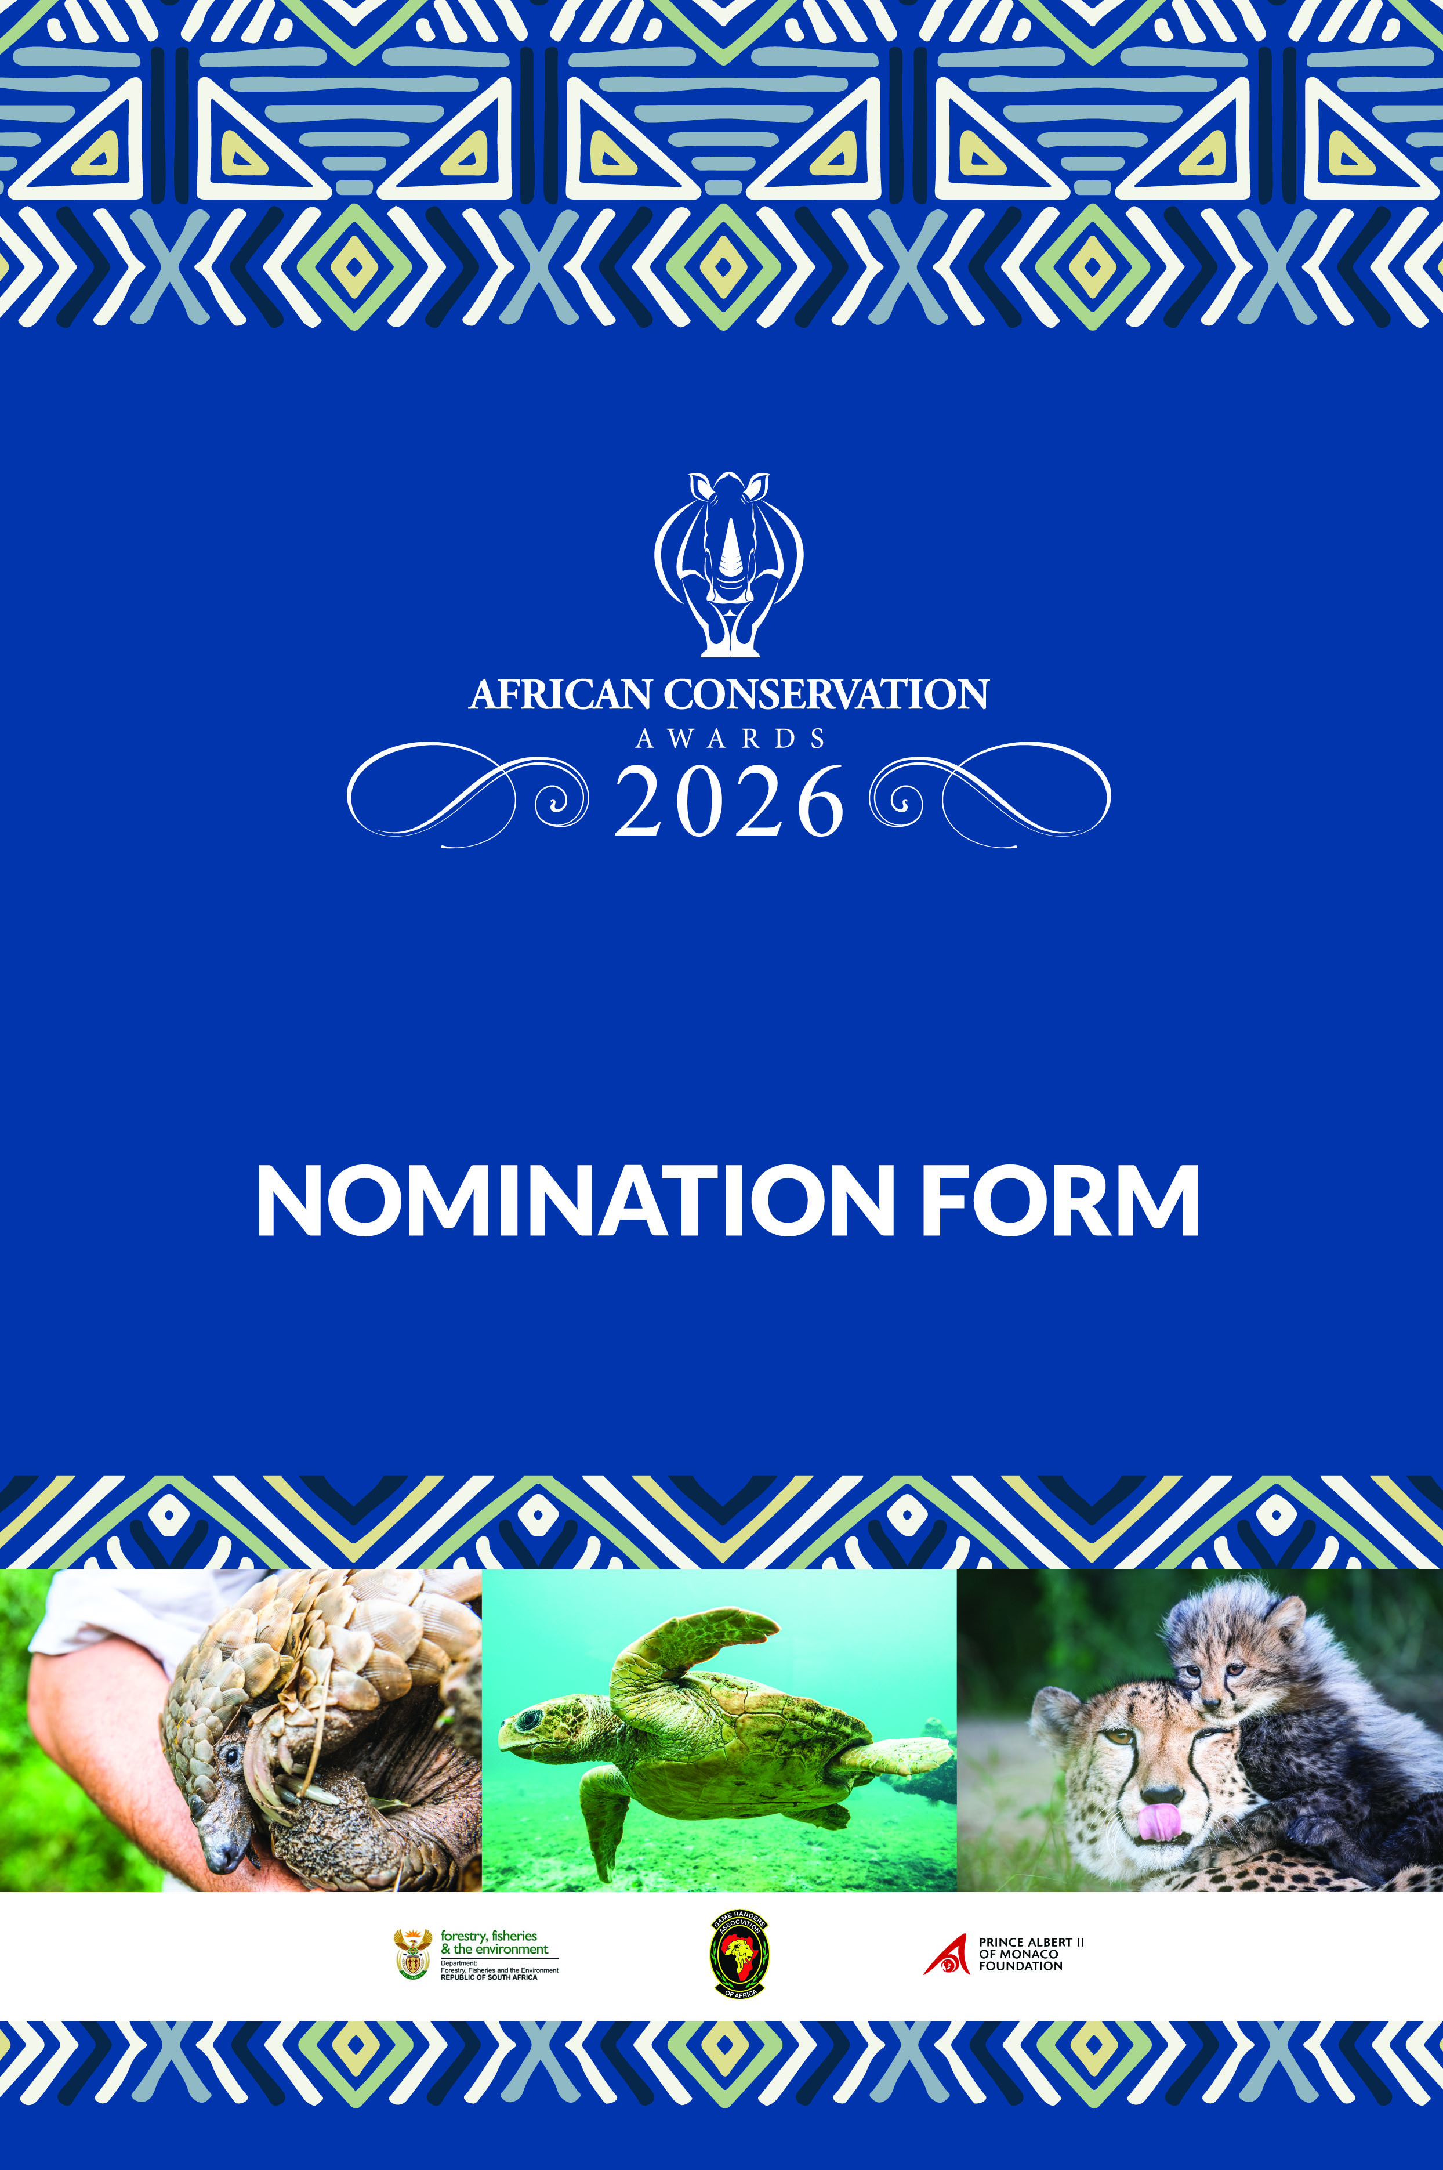
Dr Larry Hansen, and Miss Xiaoyang Yu, founded the Rhino Conservation Awards in 2011 alongside the Game Rangers’ Association of Africa to recognize significant role players involved in rhino conservation in response to the poaching onslaught that Africa’s rhinos were facing.

In 2022 the awards were relaunched as the African Conservation Awards to ensure rangers and conservation supporters working with other species were included. The primary objective of the awards is to give recognition to the leading role players in African conservation and in doing so raise awareness of their amazing work.

Often facing physical danger, political opposition and severe financial constraints, this selfless group of conservationists continue to work to save Africa’s natural heritage. The awards serve to motivate these dedicated men and women to keep fighting to ensure the survival of our wildlife and wild places for the benefit of this and future generations.

The awards are once again made possible with the support of the Game Rangers’ Association of Africa and are endorsed by the South African Department of Forestry, Fisheries, and the Environment.

2026 AWARD CATEGORIES

- Best Field Ranger:
This must be a field ranger whose exceptional work is vital to safeguarding the integrity of a terrestrial conservation area and which contributes significantly to conservation efforts.

- Best Marine Ranger:
This must be a marine ranger whose exceptional work is vital to safeguarding the integrity of a marine conservation area and which contributes significantly to conservation efforts.

- Best Ranger Team:
This must be a ranger team working in the field of conservation with a clear track record of excellence in protected area management, conservation management, counter-poaching operations, biological monitoring, human wildlife conflict mitigation or a related conservation field. This category includes ranger teams working in both marine and terrestrial conservation areas.

- Best Ranger Supporter:
This must be an individual, team or entity that plays a significant role in supporting rangers. Support can include any field including but not limited to scientific research, awareness, advocacy, education, investigations, prosecutions, judiciary, political support, community relations or fund raising.

NOMINATION PROCEDURE AND RULES

- The following five pages must be submitted as your nomination.
- Motivations should be succinct, not exceed an A4 page per section, and should follow the criteria given.
- Nominations are open to any individual/ team/ entity that meets the award criteria stipulated in the award categories.
- Self-nominations will not be accepted.
- Only details of the work done by the nominee over the last 12 months will be considered during adjudication.
- Only individuals/ teams/ entities from African countries are eligible for nomination.
- No addendums or extensions to the nomination form will be considered.
- The adjudicators may alter the nomination category should the nomination be considered to have been submitted in the wrong category.
- Nominations can be submitted in the following ways:
  - Download, complete electronically and submit by email to info@gameranger.org
  - Complete and submit a nomination on the website: www.conservationawards.africa
- Nominations close at 17h00 on Monday 3rd August 2026.
- Shortlisted candidates will be announced by Monday 31st August 2026. If you do not hear back from the organisers by then please consider your nomination unsuccessful.
- Winners will be announced on Saturday 19th September 2026 at the Regional Hub event of the Wildlife Ranger Challenge, at the Southern African Wildlife College, South Africa.
- The decision of the adjudication panel is final and no correspondence or discussion will be entered into regarding winners of the awards.

ENQUIRIES:

Marilee Gibson: +27 (0) 79 304 0446 or info@gameranger.org

NOMINEE (Individual/ team or entity that is nominated for an award):
Name:
Occupation:
Employer:
Telephone: | Landline: | Cellphone:
Postal Address:
Email Address:

NOMINATOR (Person who is submitting the nomination):

Name:
Occupation:
Employer:
Telephone: | Landline: | Cellphone:
Postal Address:
Email Address:

Please tick the category for which the nomination is submitted:

Best Field Ranger
Best Marine Ranger
Best Ranger Team
Best Ranger Supporter

- Overview of Nominee’s Work and Impact:
Provide a summary of the nominee’s work, highlighting the impact they’ve made. Use statistics, figures, and testimonials to clearly demonstrate their contribution.

- Key achievements over the past year
Detail the nominee’s significant accomplishments in the past year, emphasizing how they have exceeded expectations and gone beyond the call of duty.

- Challenges Overcome and Unique Circumstances
Explain the difficulties and obstacles the nominee faced in achieving their success. Provide specific examples of the extraordinary circumstances they have navigated.

- Leadership and influence
Describe the nominee’s leadership role within their conservation work, illustrating how they’ve inspired, guided, or influenced others to support conservation initiatives.

